Friends in Tune Seeks Singers!

Friends in Tune has launched a Quaker Virtual Choir project and would like to invite you to take part. Our aim is to record two songs using Zoom technology in order to create a video which can then be streamed to Quaker events or viewed online at Friends’ convenience. The songs are George Fox, by Sidney Carter and Truth’s a Seed by Alec Davison and Tony Biggin.

You may have seen a number of videos featuring Virtual Choirs currently doing the rounds on social media and websites. Here's an example of the kind of presentation we have in mind (ok, perhaps this is a little more ambitious than our project...!) https://youtu.be/VLPP3XmYxXg

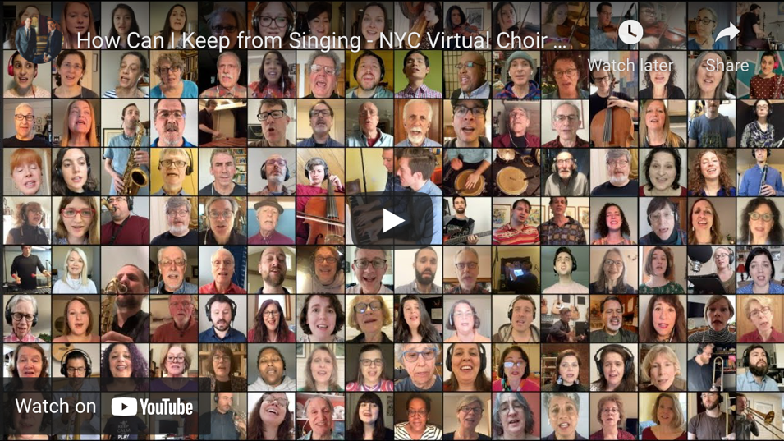
What is not often appreciated by the casual viewer us that there is usually an element of illusion within these very slick presentations. It is actually very difficult, technically, for singers to hear each other when singing on Zoom – everybody’s broadband runs at a slightly different speed which means that synchronisation is virtually impossible.
What most virtual choirs do instead is to ask participants to record their own solo voices on to their phone, computer or tablet and then send them to a producer who mixes them together afterwards. And this is what we intend to do. We will then be able to disseminate the final presentation as we wish.
Everything necessary to participate is available on the Friends In Tune website (https://friendsintune.com). Optionally there will be a Zoom rehearsal on Wednesday, May 5th at 7.30pm – 9.00pm and a Zoom video recording on Wednesday, June 9th, also from 7.30pm – 9.00pm.

If you would like to get involved (and we hope you will) please visit the website for further details or email info@friendsintune.com.

The project page on the Friends in Tune website can be found here: www.friendsintune.com/virtualchoir

We hope to hear you soon!

